StudentStringRelatedField

+++++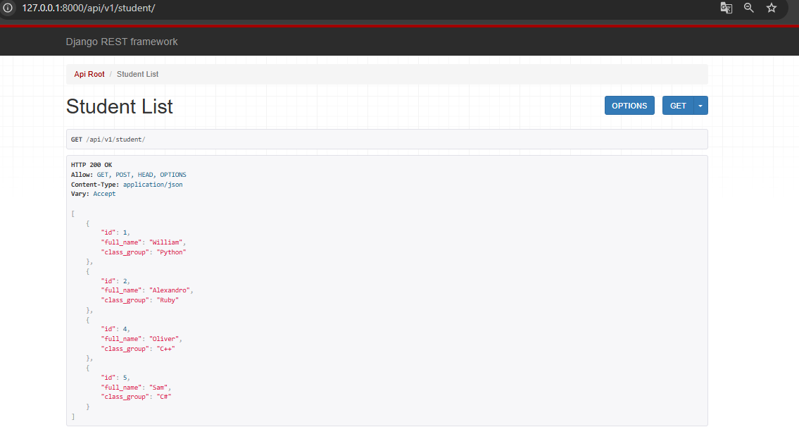

StudentPrimaryKeyRelatedField

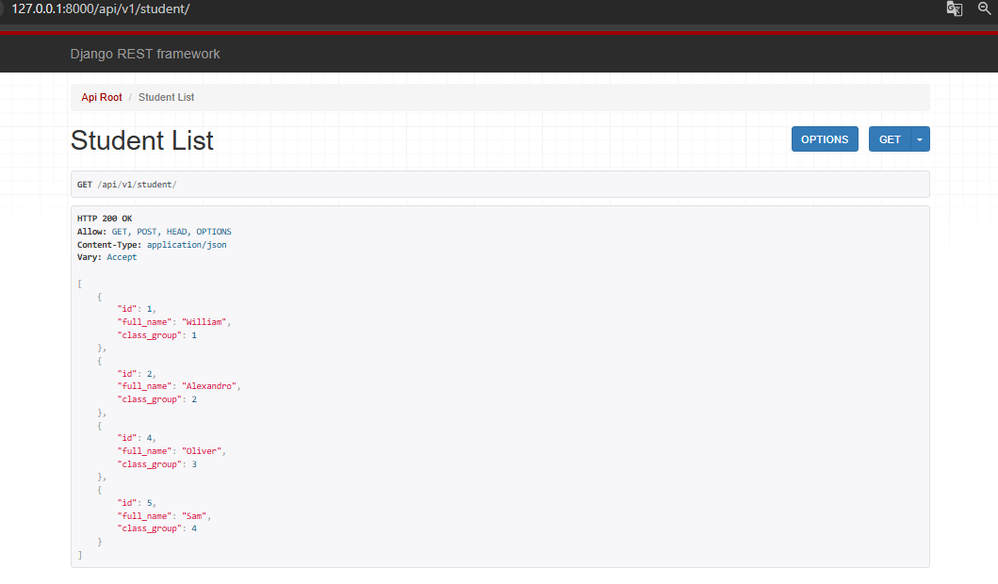

StudentHyperLinkedRelatedField

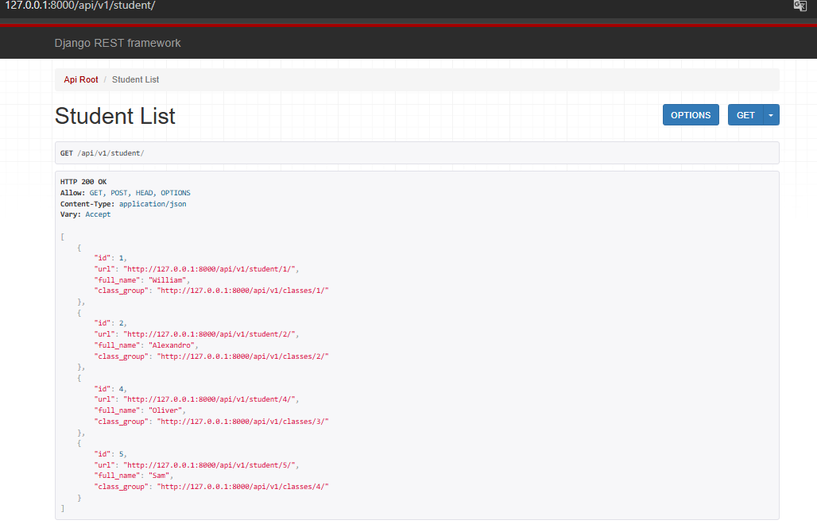

StudentSlugRelatedField

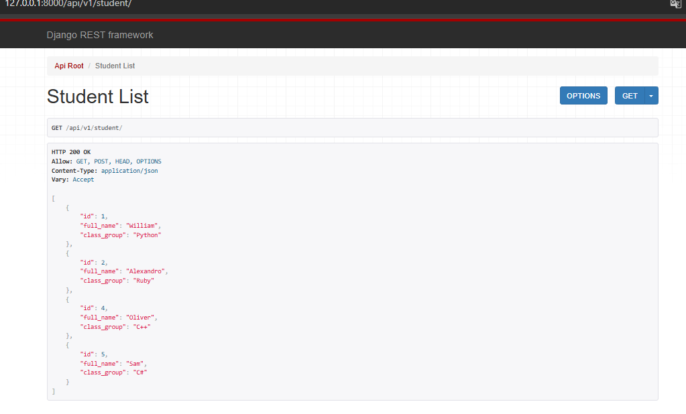

class Student(models.Model):  
 full_name = models.CharField(max_length=250)  
 class_group = models.ForeignKey(Class, on_delete=models.CASCADE)  
  
 def __str__(self):  
 return f"F.I.O {self.full_name} sinfiz {self.class_group}"

Shunga slug bir hil bop qogan

StudentHeperLinkedIdenTityField

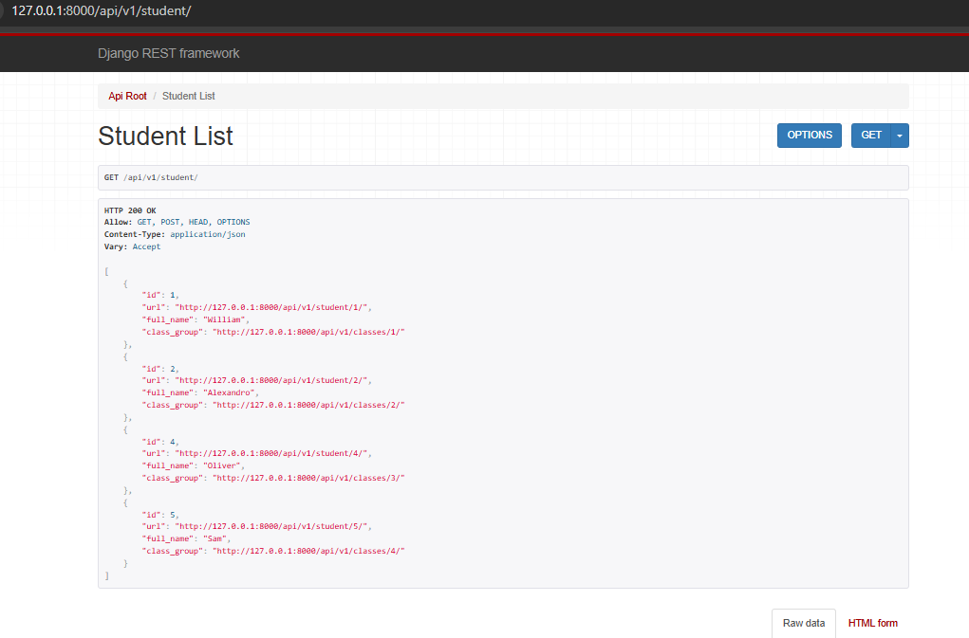

Farqi bu yerda korinmaydi shunga --->

class StudentHyperlinkedRelatedSerializer(serializers.HyperlinkedModelSerializer):  
 class_group = serializers.HyperlinkedRelatedField(view_name='class-detail', queryset=Class.objects.all())  
  
 class Meta:  
 model = Student  
 fields = ['id', 'url', 'full_name', 'class_group']  
  
  
# HyperlinkedIdentityField  
class StudentHyperlinkedIdentitySerializer(serializers.HyperlinkedModelSerializer):  
 url = serializers.HyperlinkedIdentityField(view_name='student-detail')  
  
 class Meta:  
 model = Student  
 fields = ['id', 'url', 'full_name', 'class_group']